Weekly Report Out 1

Team: Drone Link

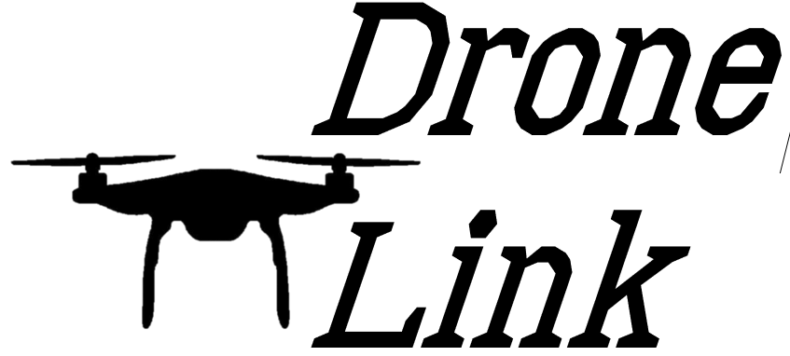Sam Forest, Alex Holt, Vincent Krenz, Lucas Larocco, Blake Masbruch

9/18/2020

Senior Design Adviser: Professor Wiedenhoeft

ScrumMaster: Vincent Krenz

Current Cadence: 0

During cadence 0 we have wireframed our project and filled our backlog with epics. From there we broke down our epics into architecture spikes to bring the team up to speed on the project ideas and the understanding of a drone race. We weighted these architecture spikes which will be completed in Cadence 1 which runs from 9/21 – 10/5. This will also help us determine what frameworks and languages to use as we proceed. We also created a team logo and name as seen above, this will help us brand our project and add to the cohesiveness of everything we work on. Along with a logo we created a working agreement that will allow us to change our expectations of the team as we go along to make sure we are always on the same page.

Our future progress will be completing half of Cadence 1 and having a better idea of what we want to use to make sure the project will be successful long term. We will also be making sure we fit into our chosen roles on the team and grow to become a well oiled machine.